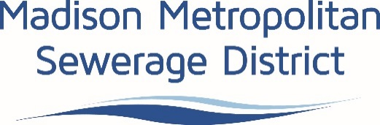

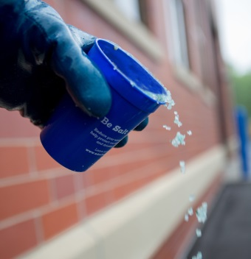
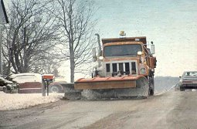
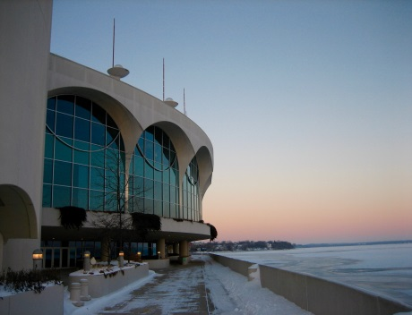
Road Salt Reduction Grant
PROGRAM INFORMATION
Madison Metropolitan Sewerage District is seeking leaders in winter maintenance! This grant is intended for aspiring leaders in the winter maintenance and snow removal profession – those who are working to reduce salt use on roadways, sidewalks, driveways and parking lots. Past grant recipients have used funding to buy equipment (new or used) or retrofit existing equipment to facilitate best management practice adoption and reduce salt use.
ELIGIBILITY
Entities that meet all the following criteria are eligible to apply for this grant:
- Work within the District’s service area;
- Committed to reducing salt use in winter maintenance practices; and
- Have at least one employee who has attended a winter maintenance training class that includes information about the environmental impacts of salt (all City of Madison Salt Certification classes count toward this requirement).
PROJECT REQUIREMENTS
To be considered for funding, proposed projects must meet all of the following criteria:
- Complete a salt reduction project in District’s service area.
- Demonstrate a measurable decrease in salt use.
- Install/complete between time of application and the following spring season.
- Develop a written winter maintenance policy.
- Share project experience. Grant recipients will be required to provide photos and other documentation for developing a case study or public outreach efforts.
- Submit completed final report including salt application data.

MATCH AND MAXIMUM AWARD
Requested grant funds shall not exceed 50 percent of total capital investment needed for the project. Typical awards range $500-$12,000 per applicant. Total available funding per year is expected to be $50,000.

APPLICATION EVALUATION
Applications will be primarily evaluated on the thoroughness and completeness of submitted application materials. Projects that will receive priority are those with clear, reasonable timelines and budgets; on sites in visible areas with educational value; and contain measurable results and have clear goals in line with the purpose of this grant. Additional consideration will be given to projects that are able to prove a change in salt use with strong quantifiable data.

REPORTING
Final reporting information should include the following:
- Quantification of salt reduction;
- Description of the method for measuring the reduction;
- Summary of knowledge gained through the pilot grant program;
- Analysis on the ease (or challenges) of integrating new equipment and practices;
- Assessment of how the project worked; and
- Summary of recommendations for other practitioners who might employ similar practices or equipment in the future.

The application and final reporting template include prompts to help applicants provide this information.

REIMBURSEMENT
Total project cost will be determined based on sales receipts provided to the District. Up to half of the total award amount, not to exceed half of the total project cost, can be reimbursed at the outset of the project, based on invoices provided by awardee. The remainder of the award funds will be reimbursed when the grant recipient provides final reporting information.

DEADLINE
Applications will be reviewed in the order in which they are received until funding is exhausted. The District reserves the right to consider special awards in the best interest of the overall chloride reduction program.

More information is available on the Chloride page of the District’s website. Case studies from previous awardees are available on the Wisconsin Salt Wise website.

Madison Metropolitan Sewerage District
Road Salt Reduction Grant - APPLICATION
Complete applications, including this application form and relevant attachments, should be sent to catherineh@madsewer.org with subject line, “Road Salt Reduction Grant Proposal.” Grants will be considered in the order in which they are received.
Note: There is no limit to length of this application; please provide attachments and use more space to answer questions as necessary.
- Eligibility and contact information
Please complete this section fully, including checking yes or no for items a) through f).
Applicant Name
(organization):
Contact Name
Contact Title
Mailing Address
Email Address
Phone Number(s)

 |  | Yes | No
a) | Will the project occur in the District’s service area? (Provide map or locations) | ☐ | ☐
b) | Are you willing to provide access to your test site(s) for video, photos, or interviews regarding this project? | ☐ | ☐
c) | Are you willing to share information about this project to aid the District’s public outreach efforts (pictures, data for case studies, short videos)? | ☐ | ☐
d) | Are you willing to accept partial funding for this project? | ☐ | ☐
e) | Do you have, or will you develop, a winter maintenance policy? | ☐ | ☐
f) | Applicant (or at least one employee) has attended winter maintenance training with an environmental component (specifically chloride pollution). | ☐ | ☐
2. Company background and project description:
Provide a broad description of the company and reason for application.

3. Proposed activities for grant-funded project:
Tell us the equipment you plan to purchase and the specific actions that will reduce salt use. Please be specific about how this equipment purchase will save your company salt and/or how experiences from this project can be transferred to others.

4. Anticipated results:
What do you estimate salt savings to be as a result of this project? How do you plan on measuring reduction in salt use, changes in management, behavior or social norms throughout the course of the project?

5. Project timeline:
Please outline the timeline for ordering equipment, starting to use it and any other relevant details.

6. Implementation address(s) or relevant maps (provide attachments as necessary):

7. Project budget
Please provide an itemized summary of project expenses in the chart below. Attach product quotes/invoices to this application. Grant funds cannot be used to support purchase of chloride containing products.

Item | Company | Cost | In-Kind Support | Final Cash Cost
 | Total:

Total project cost $________
Requested support from the District $________ (up to 50 percent of total capital expenditure)

8. Description of current operations:
- What are your mechanical snow removal practices and policies? (shoveling/snow blowing/plowing/sweeping, and when do you mobilize?)
- What are your current de-icing/salting practices (attach a copy of existing salt application policy, if available)? Include how much you use, where you use it and what you use. Provide specifics on ratios for brine application and sand/salt mixtures, if applicable.
- What equipment do you use for physical removal and for salt/de-icing material application?
- What barriers prevent individuals and your organization as a whole from optimizing salt use?
- Describe your salt storage location.
- Approximately how much do you spend per winter on de-icing salt/chemicals? Please include cost itemized by product.
- Provide an estimate of how much product was used in the past 3-5 winter seasons (e.g. rock salt, sand, sand/salt mix, brine, bagged salt or some other products). Feel free to replace the template with a format that best represents your organization’s annual product usage.
Winter season (years): | Winter season (years): | Winter season (years): | Current season – to be provided as part of grant reporting.

Madison Metropolitan Sewerage District
Road Salt Reduction Grant – REPORTING
After the project is complete, submit this completed questionnaire and a final invoice for remaining award funds disbursement. Detailed information helps inform future improvements to this grant and builds case studies that can be shared with others in the region.

- What do you consider the greatest successes of this project?

- What did you consider the greatest challenges or opportunities for improvement?

- How did your practices change as a result of this project?

- Did this project lead to reduced salt use? Please provide an estimate of how much, including information about how you calculated that estimate.

- How do you intend to continue reducing salt use practices in the future? (Which practices will you continue? Which new ones will you add? What resources will you need?)

- Did you experience any challenges using this funding program?

